U1M9.LW.Partitioning

# 2. Oracle Architecture - Partitioning

## 2.1. Task 01: CREATE Example of Range partitioning

**The Main Task** is to creating example of range partitioning table. Perform Administration tasks on all partitioning types:

| Maintenance Operation | Range Composite Range-* | Interval Composite Interval-* | Hash | List Composite List-* | Reference |
| --- | --- | --- | --- | --- | --- |
| [Adding Partitions](http://docs.oracle.com/cd/B28359_01/server.111/b32024/part_admin.htm#i1007318) | ADD PARTITION | ADD PARTITION | ADD PARTITION | ADD PARTITION | N/A[Foot 1](http://docs.oracle.com/cd/B28359_01/server.111/b32024/part_admin.htm" \l "BAJCBJBA) |
| [Coalescing Partitions](http://docs.oracle.com/cd/B28359_01/server.111/b32024/part_admin.htm#i1007442) | N/A | N/A | COALESCE PARTITION | N/A | N/A[Footref 1](http://docs.oracle.com/cd/B28359_01/server.111/b32024/part_admin.htm" \l "sthref213) |
| [Dropping Partitions](http://docs.oracle.com/cd/B28359_01/server.111/b32024/part_admin.htm#i1007479) | DROP PARTITION | DROP PARTITION | N/A | DROP PARTITION | N/A[Footref 1](http://docs.oracle.com/cd/B28359_01/server.111/b32024/part_admin.htm" \l "sthref214) |
| [Merging Partitions](http://docs.oracle.com/cd/B28359_01/server.111/b32024/part_admin.htm#i1007638) | MERGE PARTITIONS | MERGE PARTITIONS | N/A | MERGE PARTITIONS | N/A[Footref 1](http://docs.oracle.com/cd/B28359_01/server.111/b32024/part_admin.htm" \l "sthref215) |
| [Moving Partitions](http://docs.oracle.com/cd/B28359_01/server.111/b32024/part_admin.htm#i1007920) | MOVE PARTITION | MOVE PARTITION | MOVE PARTITION | MOVE PARTITION | MOVE PARTITION |
| [Splitting Partitions](http://docs.oracle.com/cd/B28359_01/server.111/b32024/part_admin.htm#i1008028) | SPLIT PARTITION | SPLIT PARTITION | N/A | SPLIT PARTITION | N/A[Footref 1](http://docs.oracle.com/cd/B28359_01/server.111/b32024/part_admin.htm" \l "sthref216) |
| [Truncating Partitions](http://docs.oracle.com/cd/B28359_01/server.111/b32024/part_admin.htm#i1008226) | TRUNCATE PARTITION | TRUNCATE PARTITION | TRUNCATE PARTITION | TRUNCATE PARTITION | TRUNCATE PARTITION |

**Task Results:**

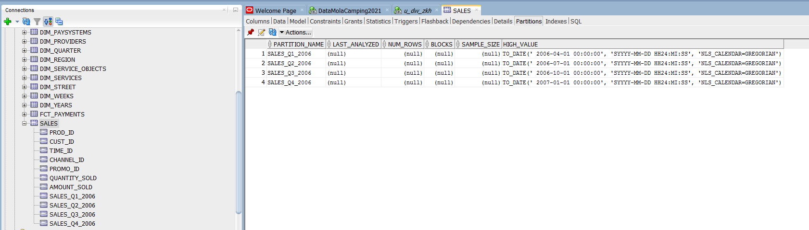

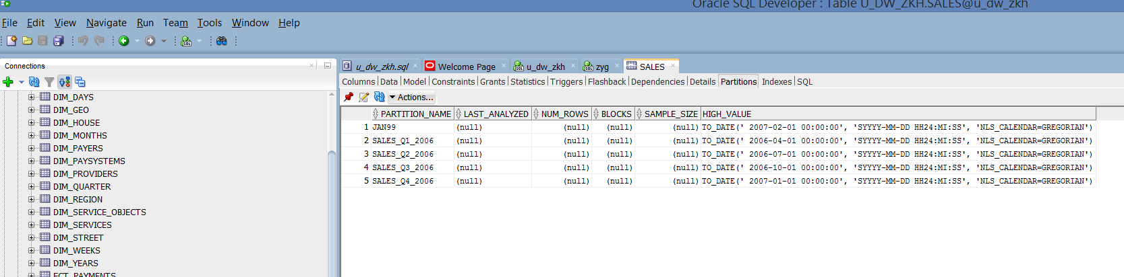

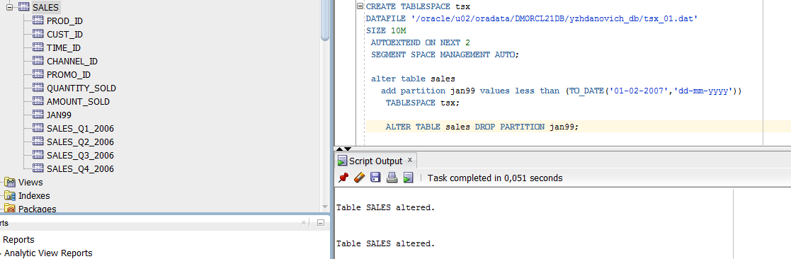

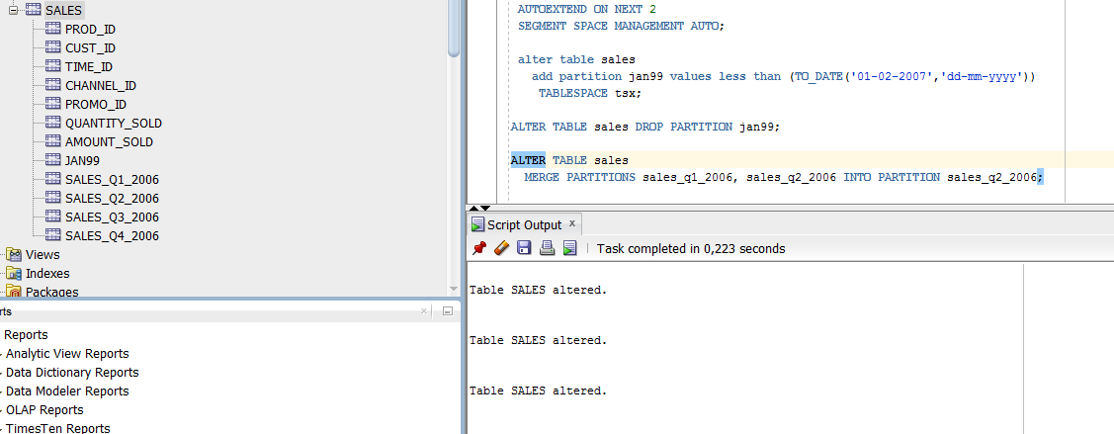

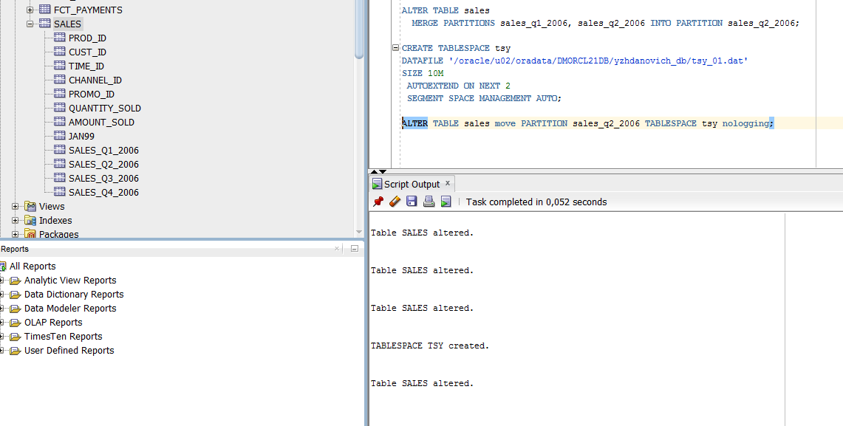

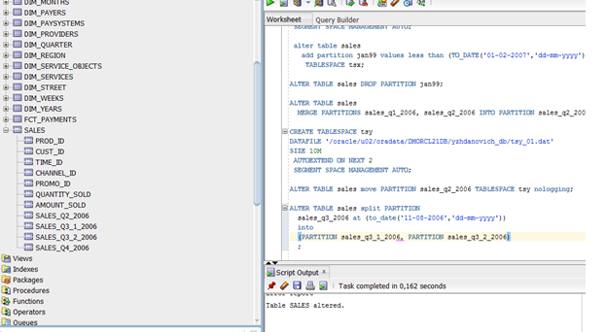

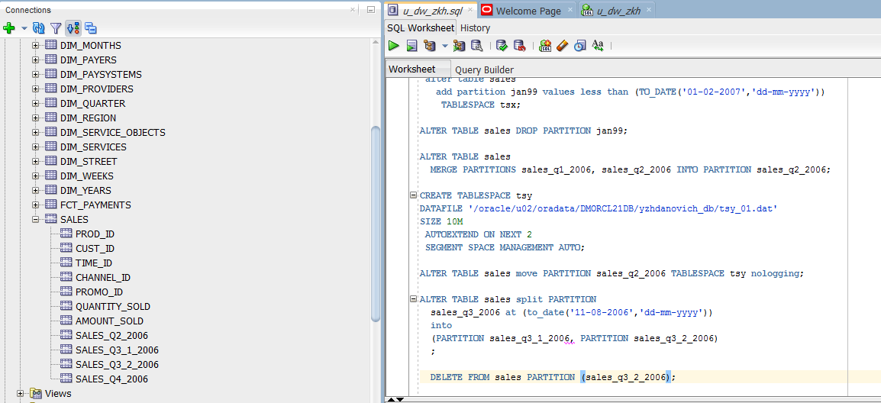

# 3. Business Task - Partitioning Facts

## 3.1. Task 02: Partitioning Facts

**The Main Task** is to partitioning Fact table that you create and describe on yours Solution Concept

Default partitioning scheme:

* Range by Even_dt (Daily, Monthly …)
* Hash by one of IDs (4 Subpartitions)

**Task Results:**

* Add chapter to Solution Concept describing Partitioning rules on Fact Tables.
* Change Creation Script for Fact Table.

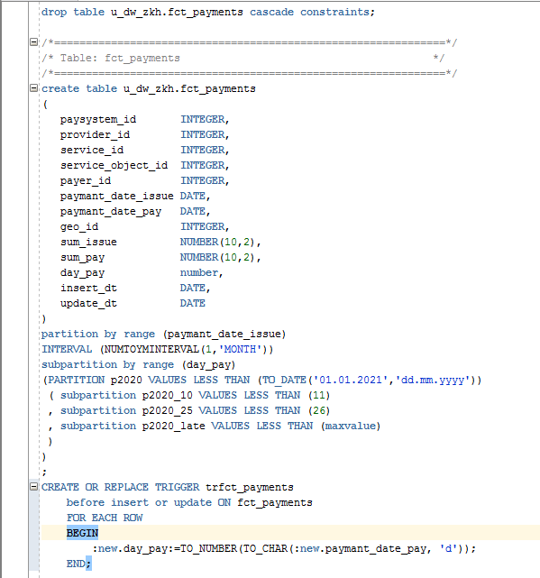

**Conclusions**

Partitioning improves the efficiency of working with tables and indexes, allowing you to solve the problems described at the beginning of this article. An important step is to determine the partitioning key. In Oracle it is possible to use a virtual column as the partitioning key. If it is not possible to identify the partitioning key, consider using HASH or system partitioning methods. Choosing a partitioning method according to a specific choice of partitioning method has been enhanced in Oracle. An important point of introducing a new section. The article proposes three methods: developing a procedure for automatically creating a partition that is started periodically from a JOB; the next approach is to use partitioning by using or using interval partitioning. Partitioning a table allows you to create more subsections within a section, while in Oracle the number of section-subsection method combinations has been significantly expanded.